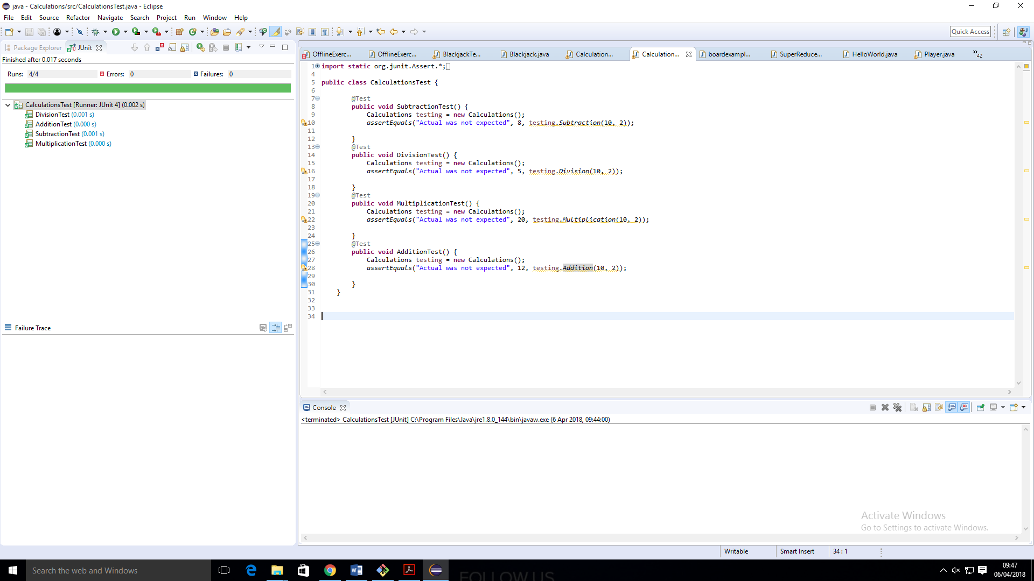 **DevOps Assessment Project** 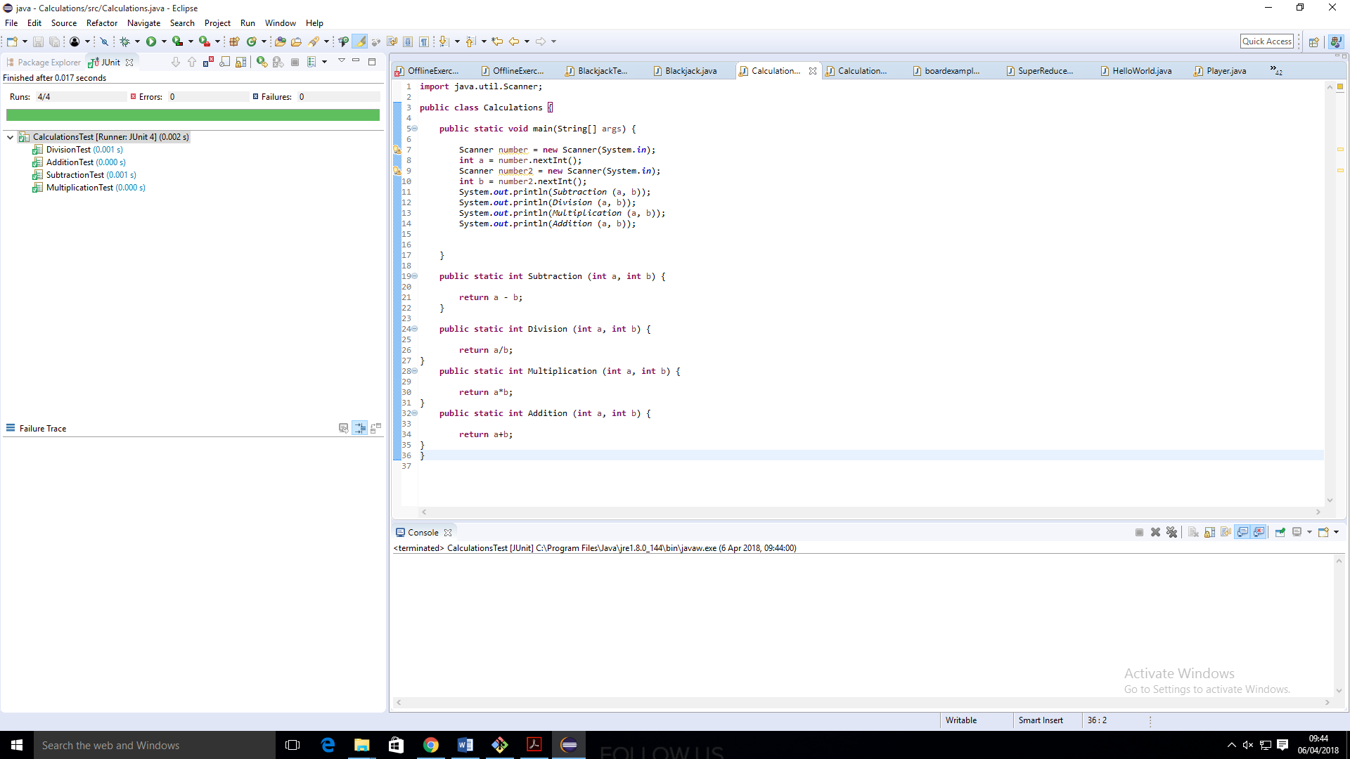

1.

I created a simple application that subtracts, divides, multiplies and adds the same two numbers inputted by the user. I then used Junit to test each of these calculation methods.

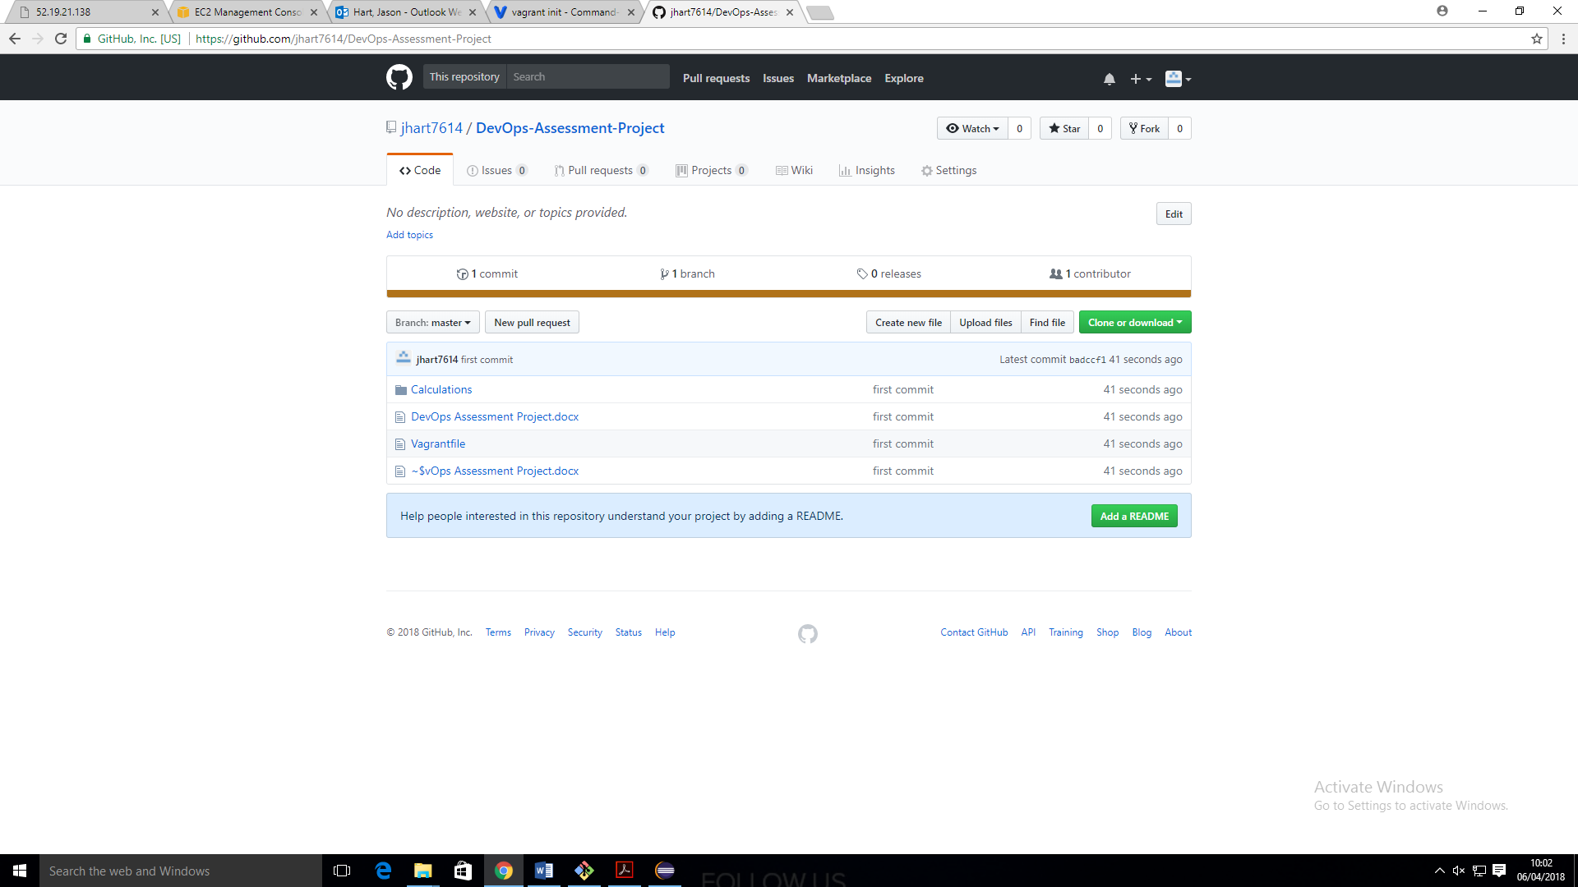

2.

I then created a new repository for the project and pushed the java files to this repository.

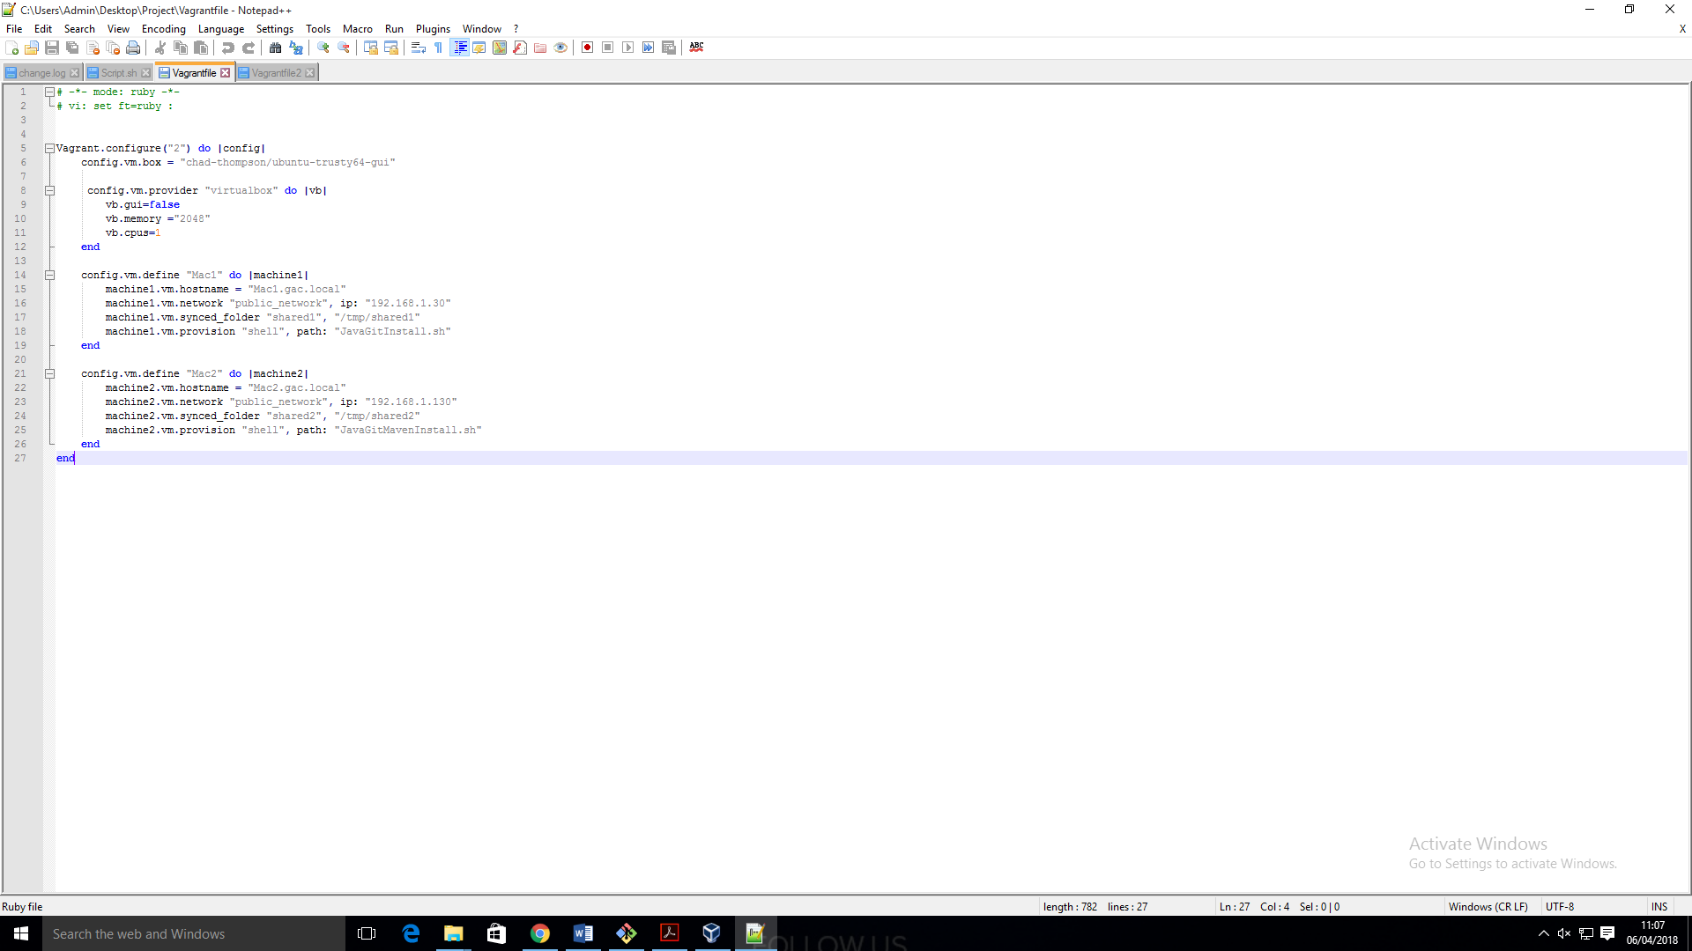

3.

Using this vagrantfile I created two virtual machines each with their own network capabilities and shared folders and with GUI disabled for both.

4.

Bash scripts are then used to install git, java and maven on both machines and then are checked in the Ubuntu terminal.

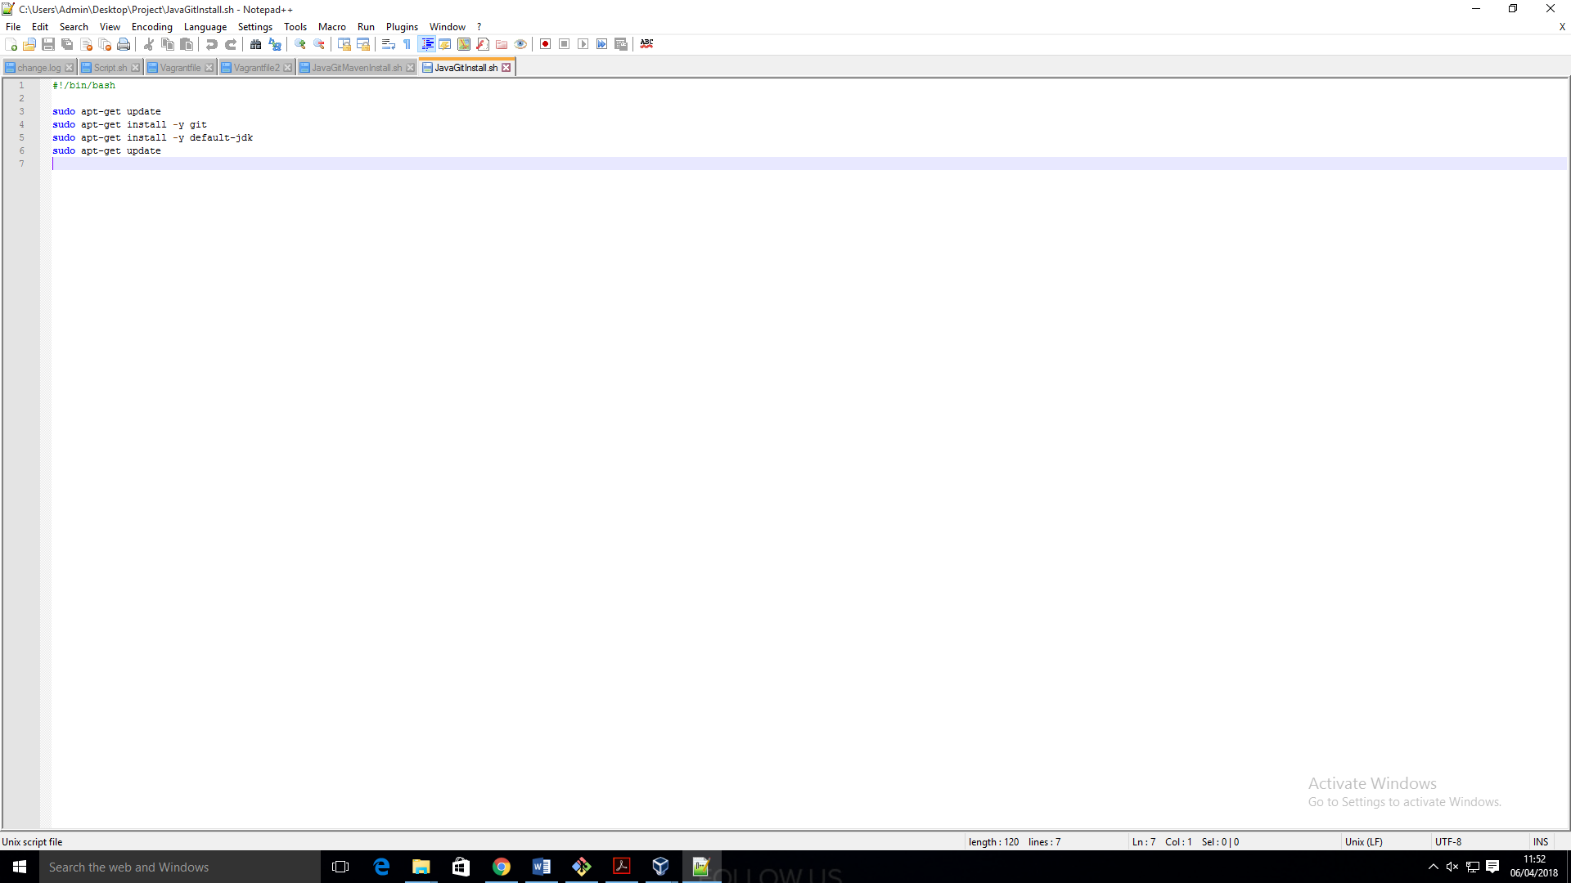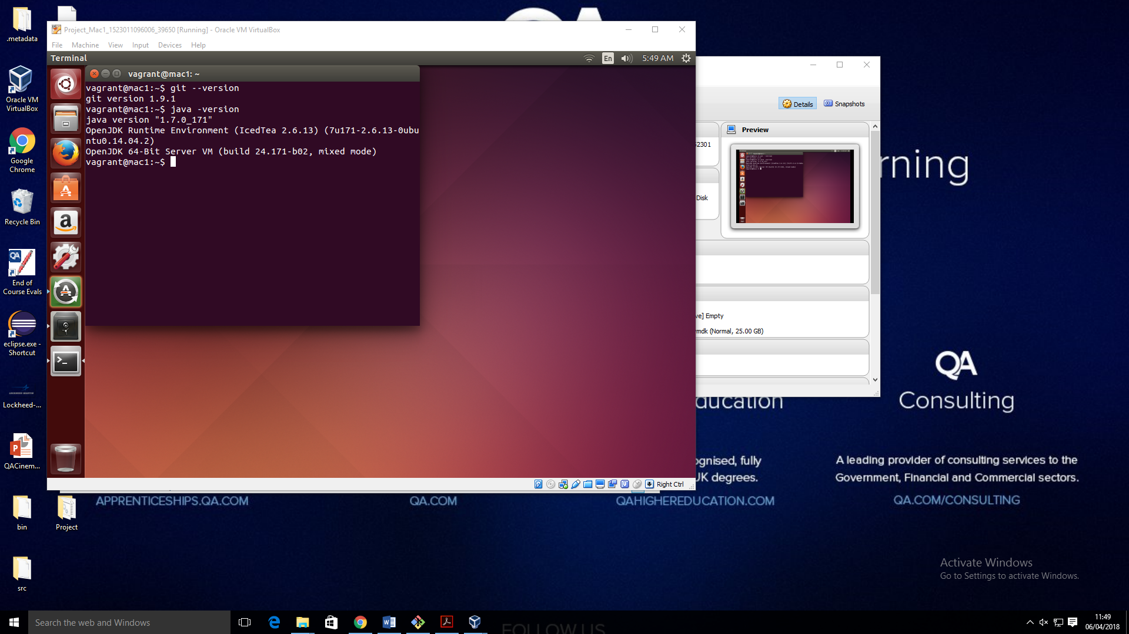

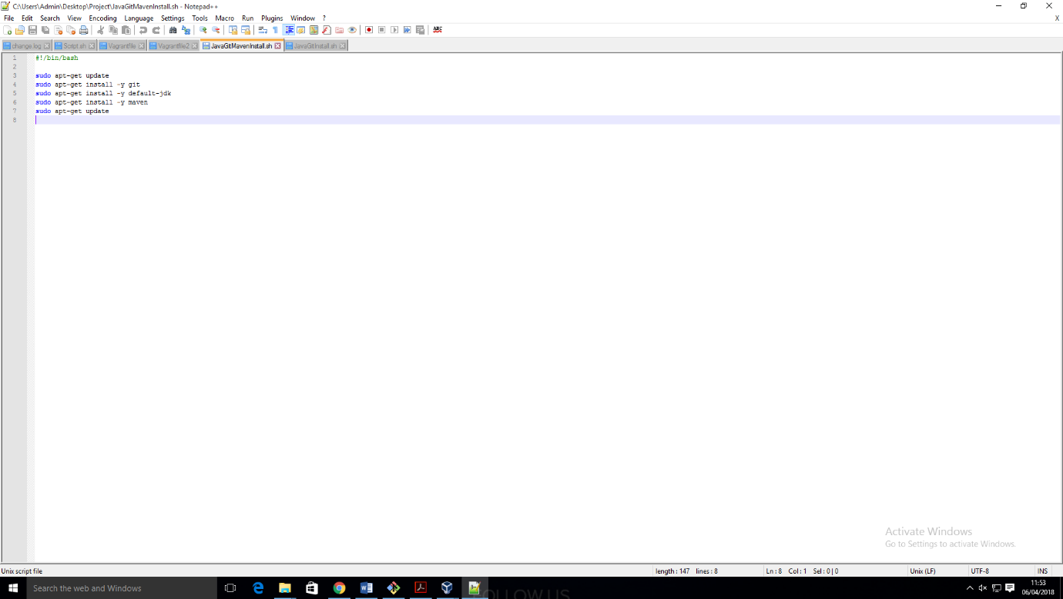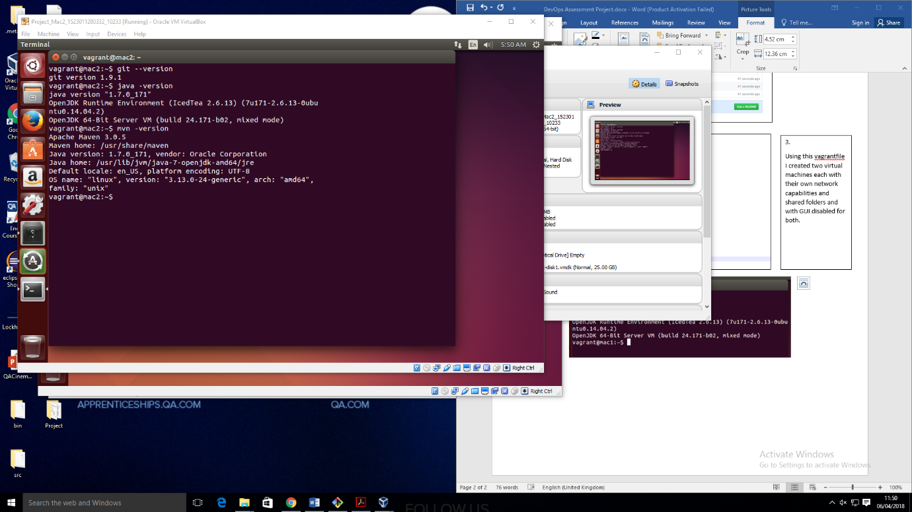

5. I then pulled the directory from github to my shared folder for machine 1 and made 4 script files in the same directory. The I pushed these scripts to git.

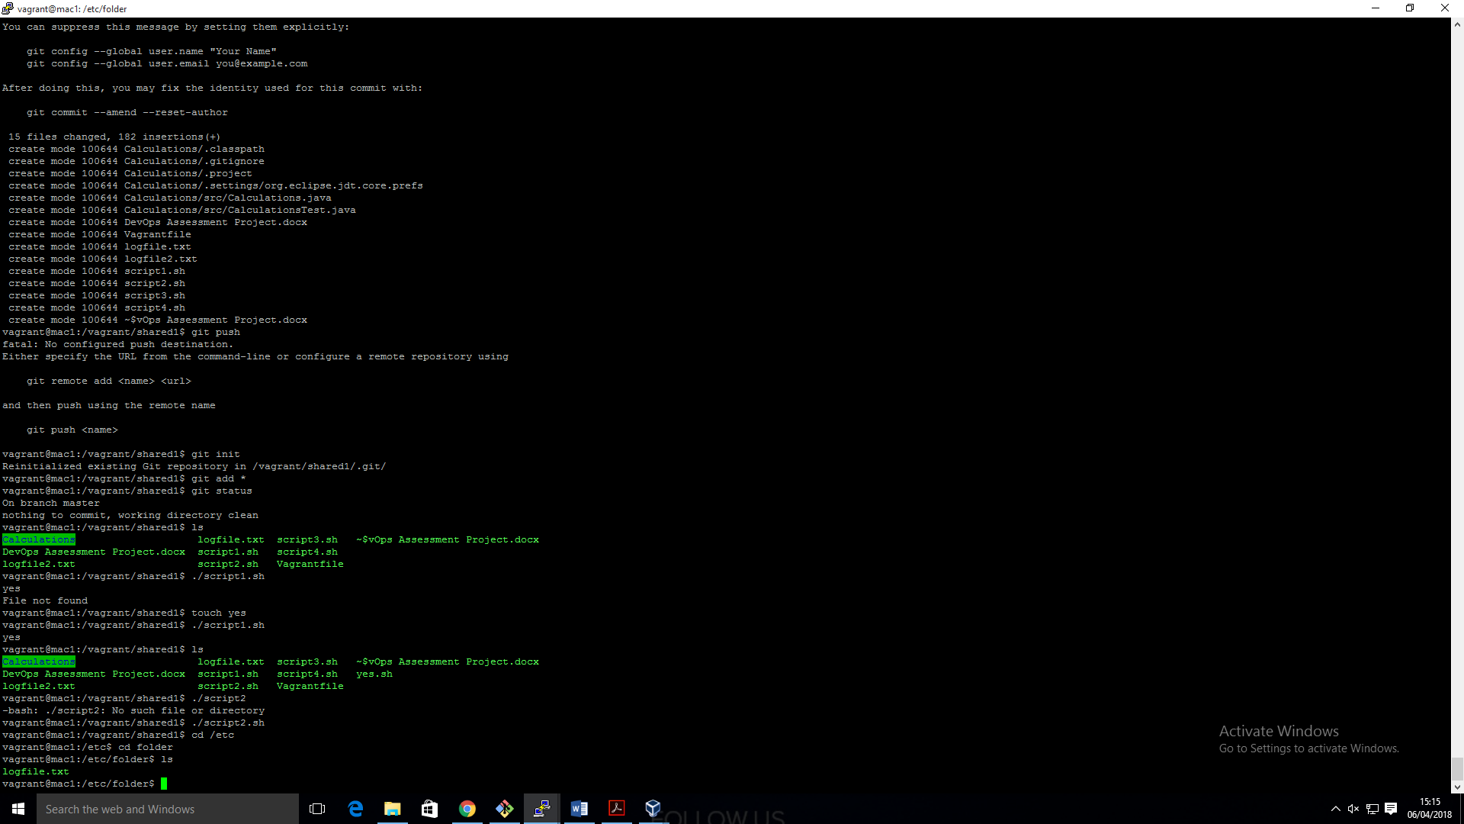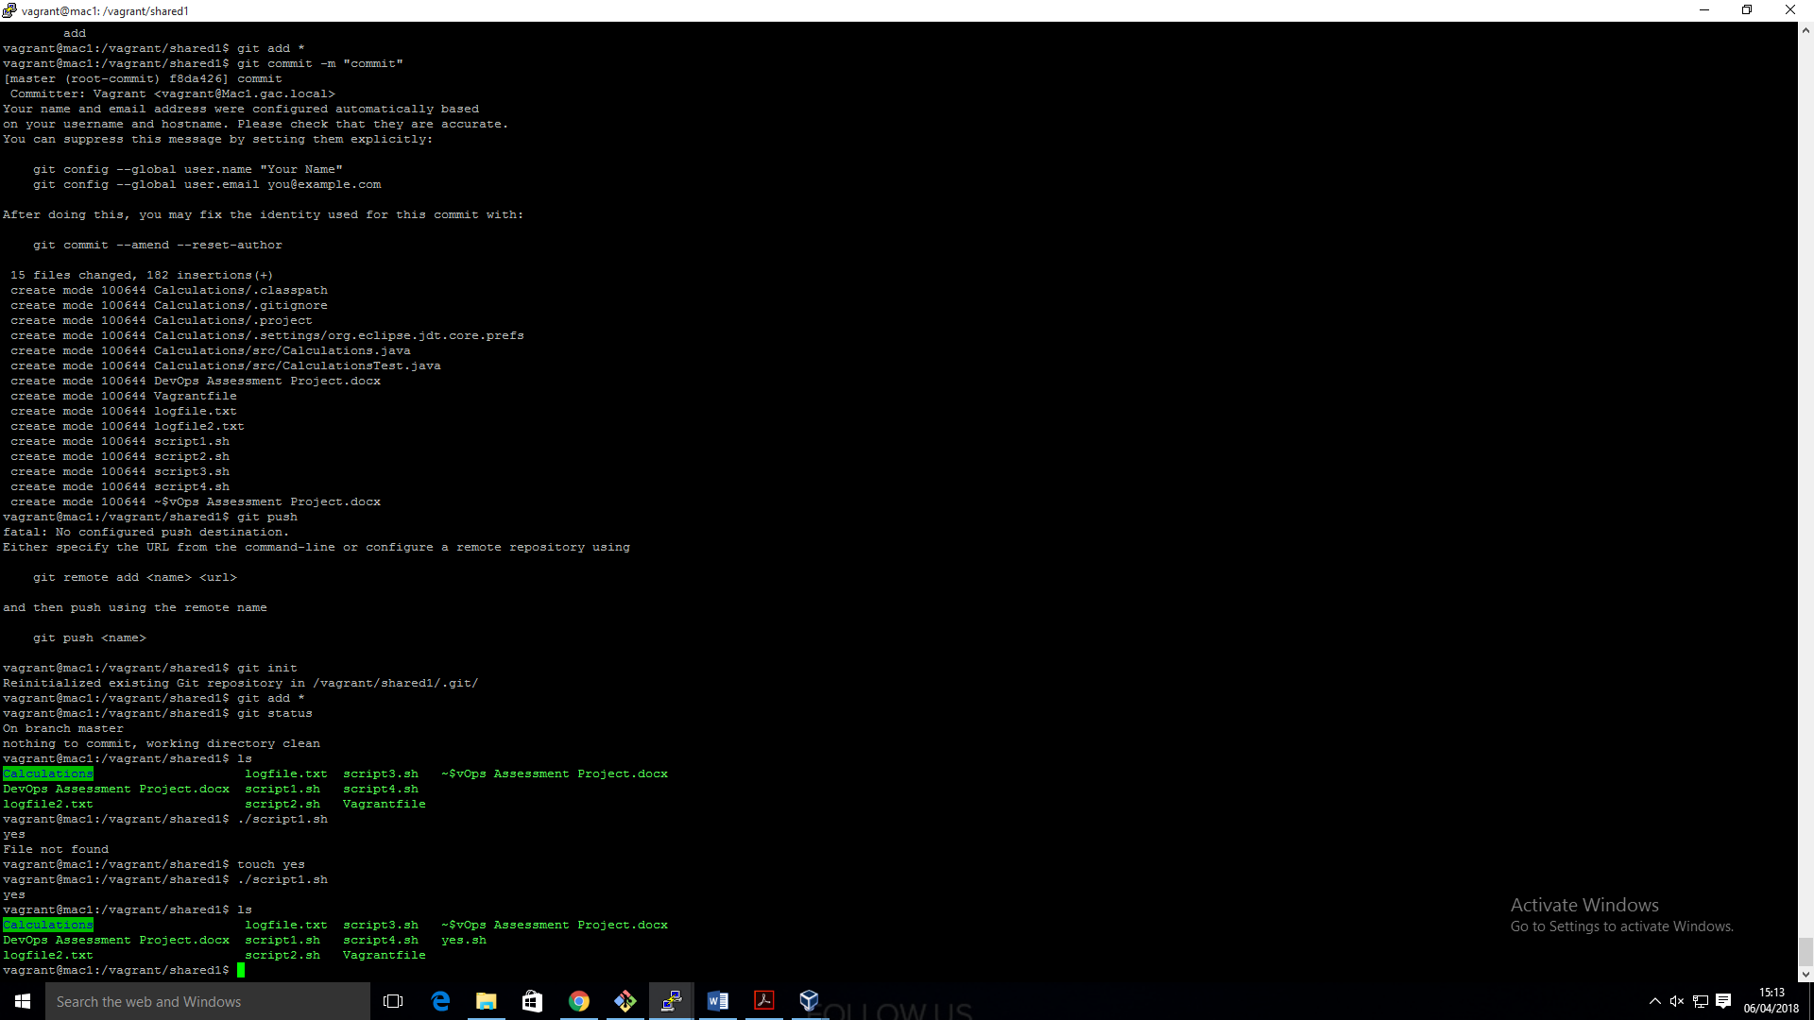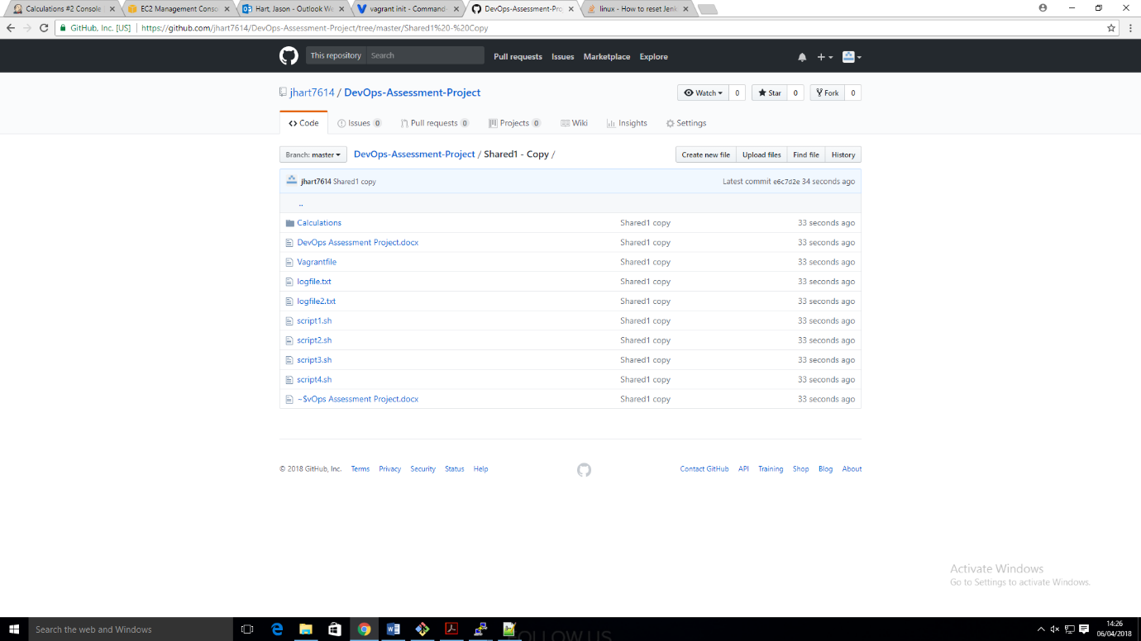

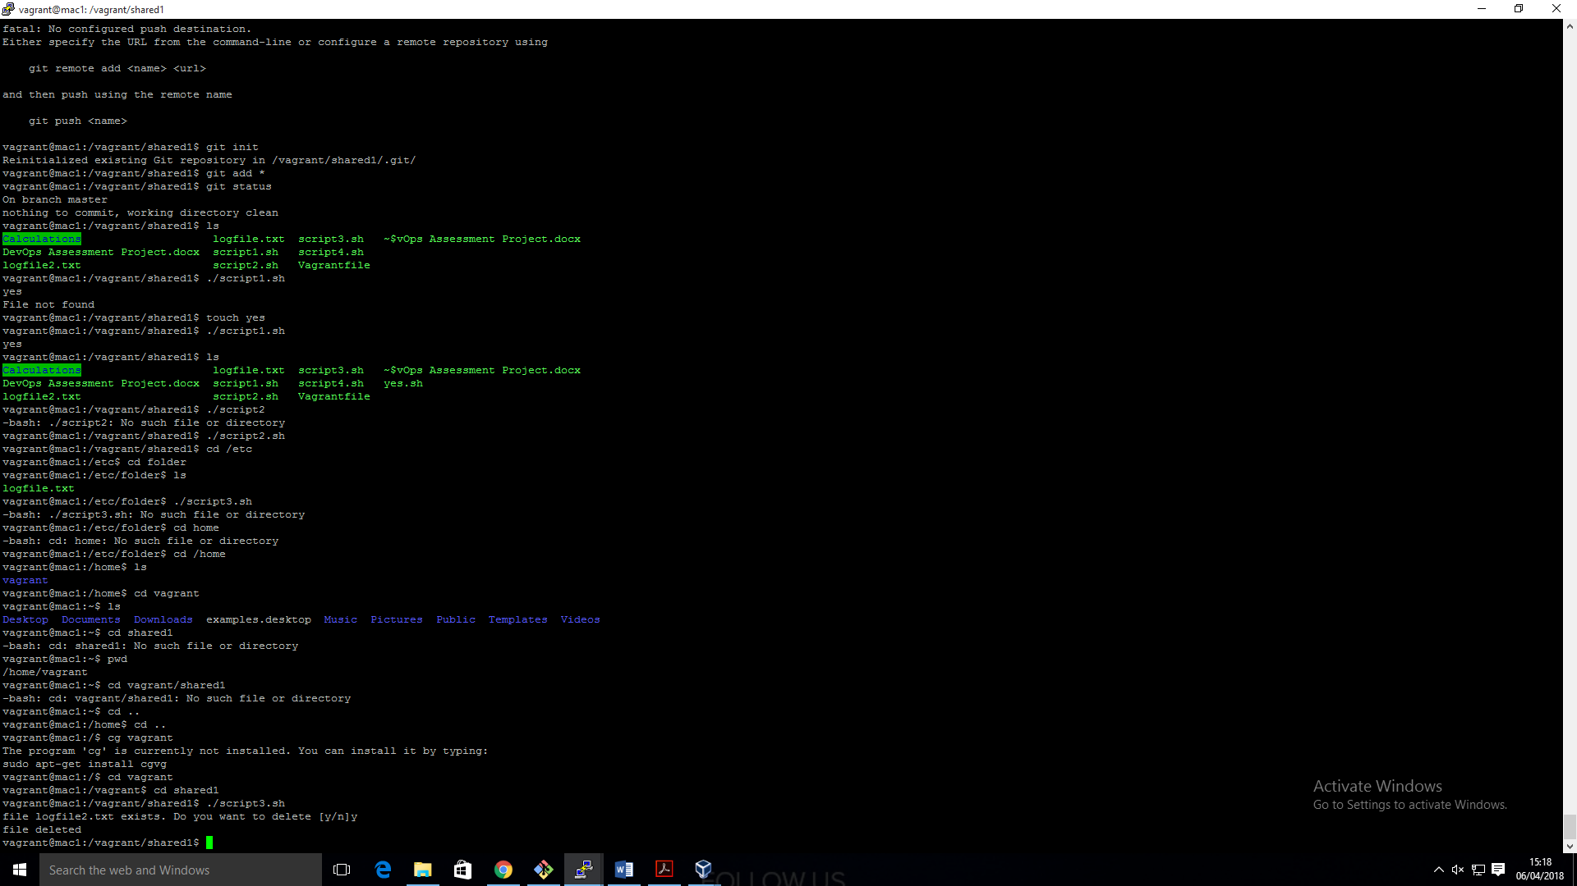

6.

I then made a job that built the calculation java application but it failed.

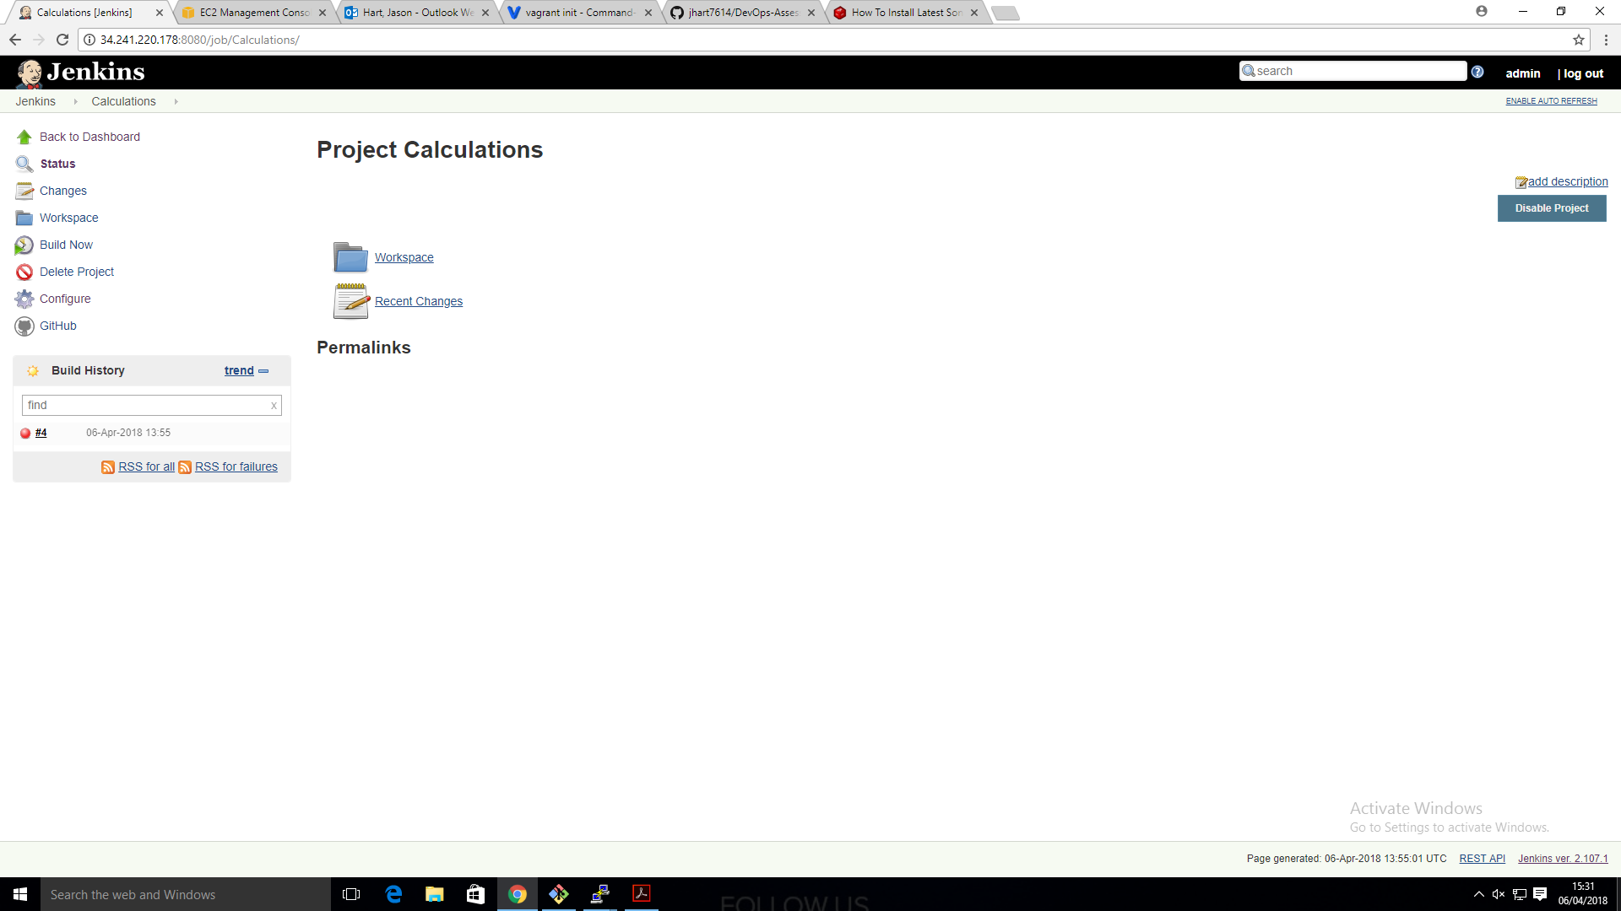

6. I then Installed nexus on my 2nd virtual machine using these commands in the linux terminal

$ sudo wget <https://sonatype-download.global.ssl.fastly.net/nexus/3/nexus-3.0.2-02-unix.tar.gz>

$ sudo tar -xvf nexus-3.0.2-02-unix.tar.gz

$ sudo mv nexus-3.0.2-02 nexus

